**Common input controls**

Text <input type=”text”>

Password <input type=”password”>

Checkbox <input type=”checkbox”>

Radio button <input type=”radio”>

Large text area <textarea>

Hidden field <input type=”hidden”>

Submit button <input type=”submit”>

Image submit button <input type=”image”>

Reset button <input type = “reset”>

Select Menu <select>

<option>

</select>

// generates random

$randNum = rand(1,100);

**Assign**

$var1 = 83.23

$dailyTemp = array(‘Sunday’ => 75);

**Special**

* Identical ===
* Not identical !==

$a = 1;

$b = 1.0;

$comp1 = ($a == $b); // true

$comp2 = ($a === $b) ; // false

Null

* If variable has not been assign a value
* Assigned with NULL
* With function unset()

Special operators



if if/else switch while do-while for foreach

! && || and xor or

**CONSTANTES**



|  |  |
| --- | --- |
| **VARIABLES** | **CONSTANTES** |
| $variable = 1; // lleva $ | constant=1; // no lleva $ |
| $variable_string = “si usa doble”; | string_constant = ‘no doble’ ; |





CONVENTION: USE UPPERCASE FOR CONSTANTS AND DEFINE THEN WITH ‘define’



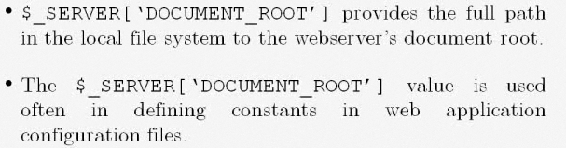

Document_root c:\xampp\thdocs